Steps to Follow for Installation of Modern Requirement’s Certificate

- Install eDev’s certificate in trusted publisher. Download it from location:
https://smartoffice4tfs.blob.core.windows.net/products/ModernRequirements.cer

- Double click on downloaded certificate file.
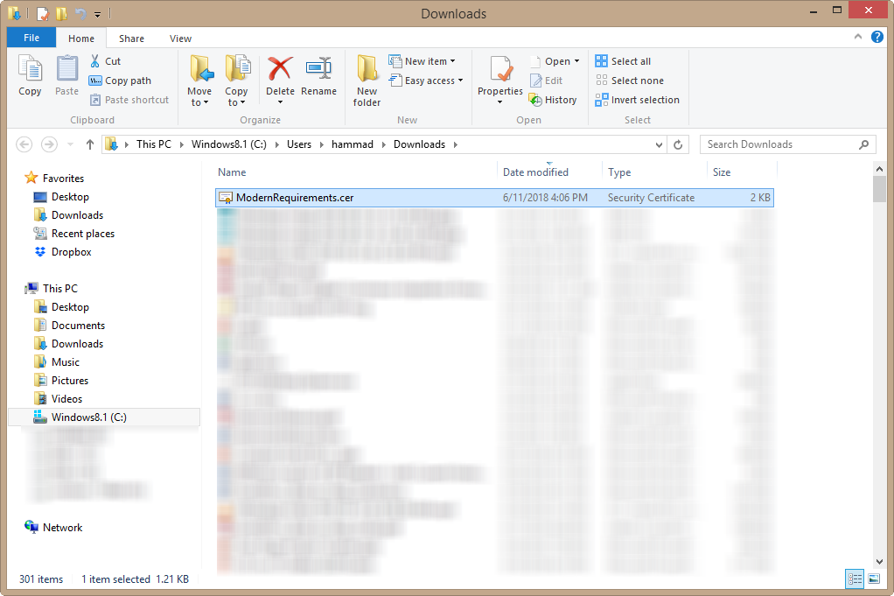

- Click “Open”:
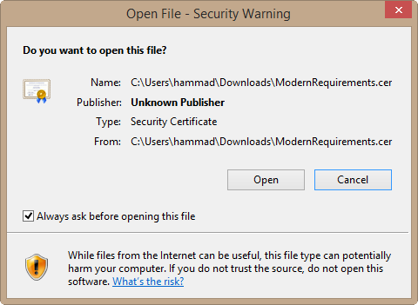

- Certificate window would be displayed, Click “Install Certificate” button.

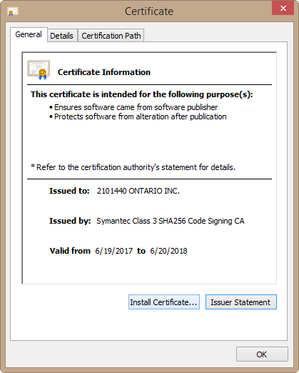

- Select “Local Machine”, Click “Next”.

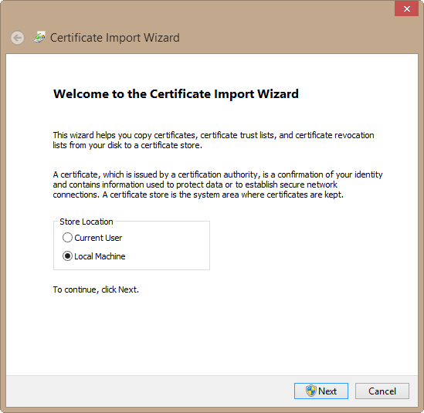

- “Certificate Import Wizard” page would be displayed. Browse and among list select “Trusted Publishers” and click “OK” then click “Next”(as shown below )

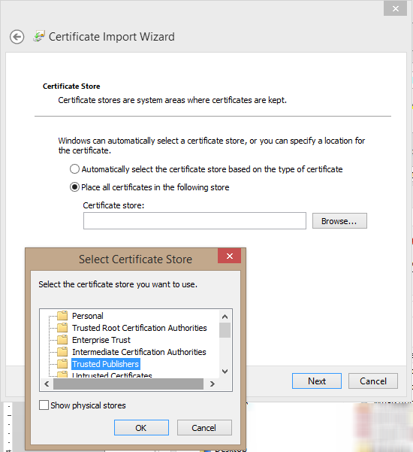

- Selected options would be displayed on page, Click “Finish”:
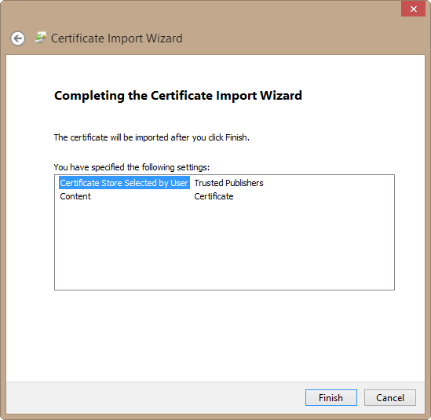

- On “Finish”, “The Import was successful.” Message window would be displayed.
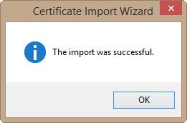

- Goto File>>Options, “Word Options” window would be displayed.

- Select “Trust Center” from left options list, Click on “Trust Center Settings..” button.

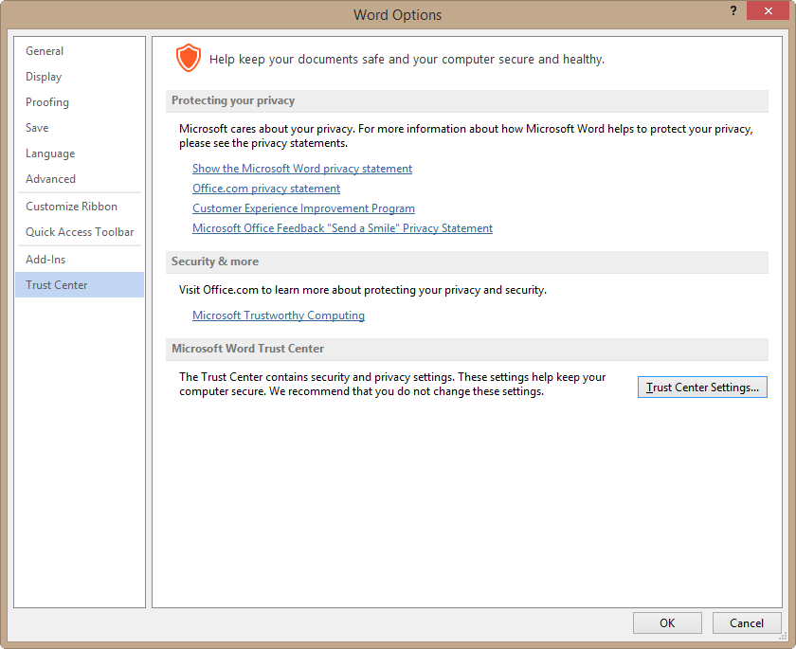

- Trust Center window would be opened, select “Trusted Locations” from left options list.
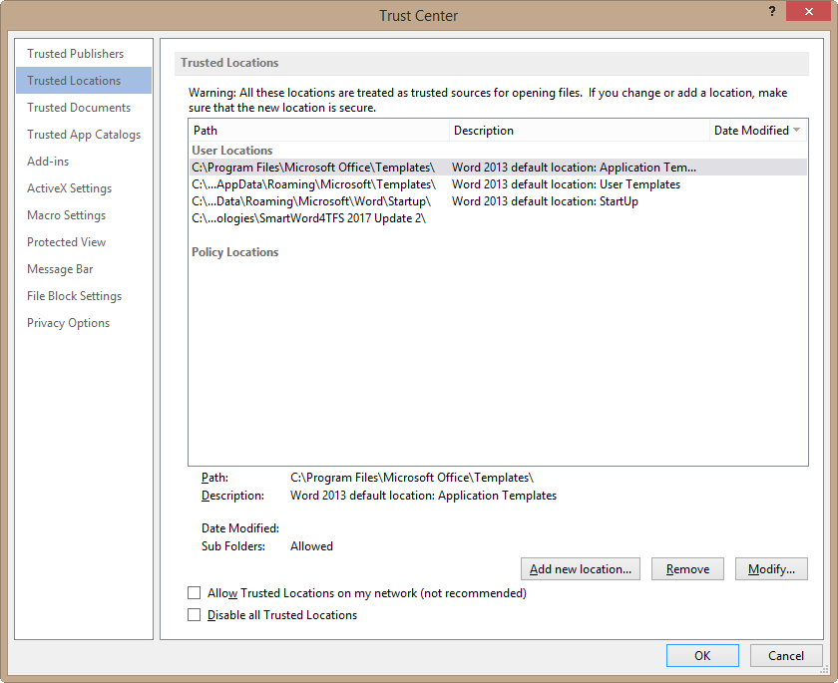

- From right pane, click “Add new location…” button, following window would be displayed.
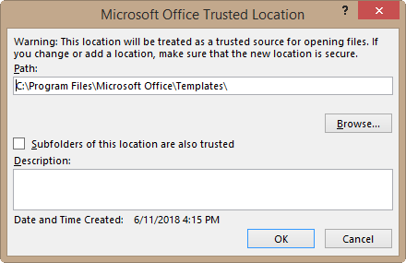
- Click “Browse…” button to select the installation location of SmartWord4TFS ( <installation directory:\Program Files\eDev Technologies ), now select checkbox “Subfolders of this location are also trusted” and click “OK”.
- Click “OK” on main window and close all windows. Close MS-WORD if opened and Re open it.

